**Manage Azure Storage**

**Task 1: Create and Configure a storage account**

Select Create

Under Basics Tab create new resource group:

Name Storage account name

Redundancy: Geo-redudant storage (GRS)

In the Networking tab, In the Network Access section, **select Disable public access and use private access** to restrict inbound access while allowing outbound access.

Review Data Protection and you will notice default soft delete retention policy is 7 days by defaults. Leave default as is or increase the number of days.

Review **Data protection** tab and Accept defaults.

Select **Review + Create** and click **create**

In the Security + networking blade change **Public network access** to **Enable from selected networks and IP addresses**

Once an account is deployed select **Go to resource**

In Security + networking blade, select Networking. Change the **Public network access** to **Enable from selected networks and IP addresses**.

In the Firewall section, Select Add your client IP address and save your changes

In the **Data management** blade, **select Lifecycle management** and then select **Add a rule**

Name Rule a name of your liking and click next

Add 30 days and hit Add

**Task 2: Create and configure secure blob storage**

**In the Data storage blade, select Containers**

**Click + Add container and Create a container within the following settings:**

Select the three dots to the right of the **Data container** created and **select Access policy**

**In the immutable blob storage area select, Add Policy**

Set Policy type value to **Time-based retention and** Set retention period for **180 days**

Return to containers page, select **data** container and then click **Upload.**

On the upload blade, expand the Advanced Section

In Browse for files upload a file you have selected to upload

Select Advanced Blob type Block blob, Block size 4 MiB, Access tier Hot, Upload to folder: Security test, Encryption leave as is. Select Upload.

Go settings and select properties and copy URL and enter URL into browser

Select three dots and select **Generate SAS**

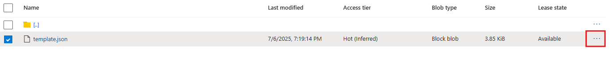

Signing key: key 1, Permissions: Read, Start date: yesterday’s date, Start time: current time, Expiry date: tomorrow’s date, Expiry time: current time, Allowed IP addresses: leave blank

**Copy Blob SAS URL and paste into InPrivate Window Browser**

**Task 3: Create and configure Azure File Storage**

Under Data storage select File shares

Click + File share on the Basics tab gives the file share a name, **share1**

Make sure Enable Backup is unselected and Click Review + create, and then Create

In the Storage account select **Storage browser**

Select **File shares** and verify **share1** is present

**Restrict network access the storage account**

In the portal search for and select **Virtual Networks**

Select Review + create and then Create

Go to Resource and in the settings section, select the Service endpoints blade and Select Add

In the Services drop down select **Microsoft.Storage**

In the Subnets drop-down check, the Default **subnet** and select **Add** to save your changes

In the Security + networking blade, select networking and Select Add existing virtual network and select vnet1 and **default** subnet, select **Add**

Delete Machine IP address and Save your changes

=

Navigate to Storage browser and Refresh

